LINE CHART - MONTHLY SALES
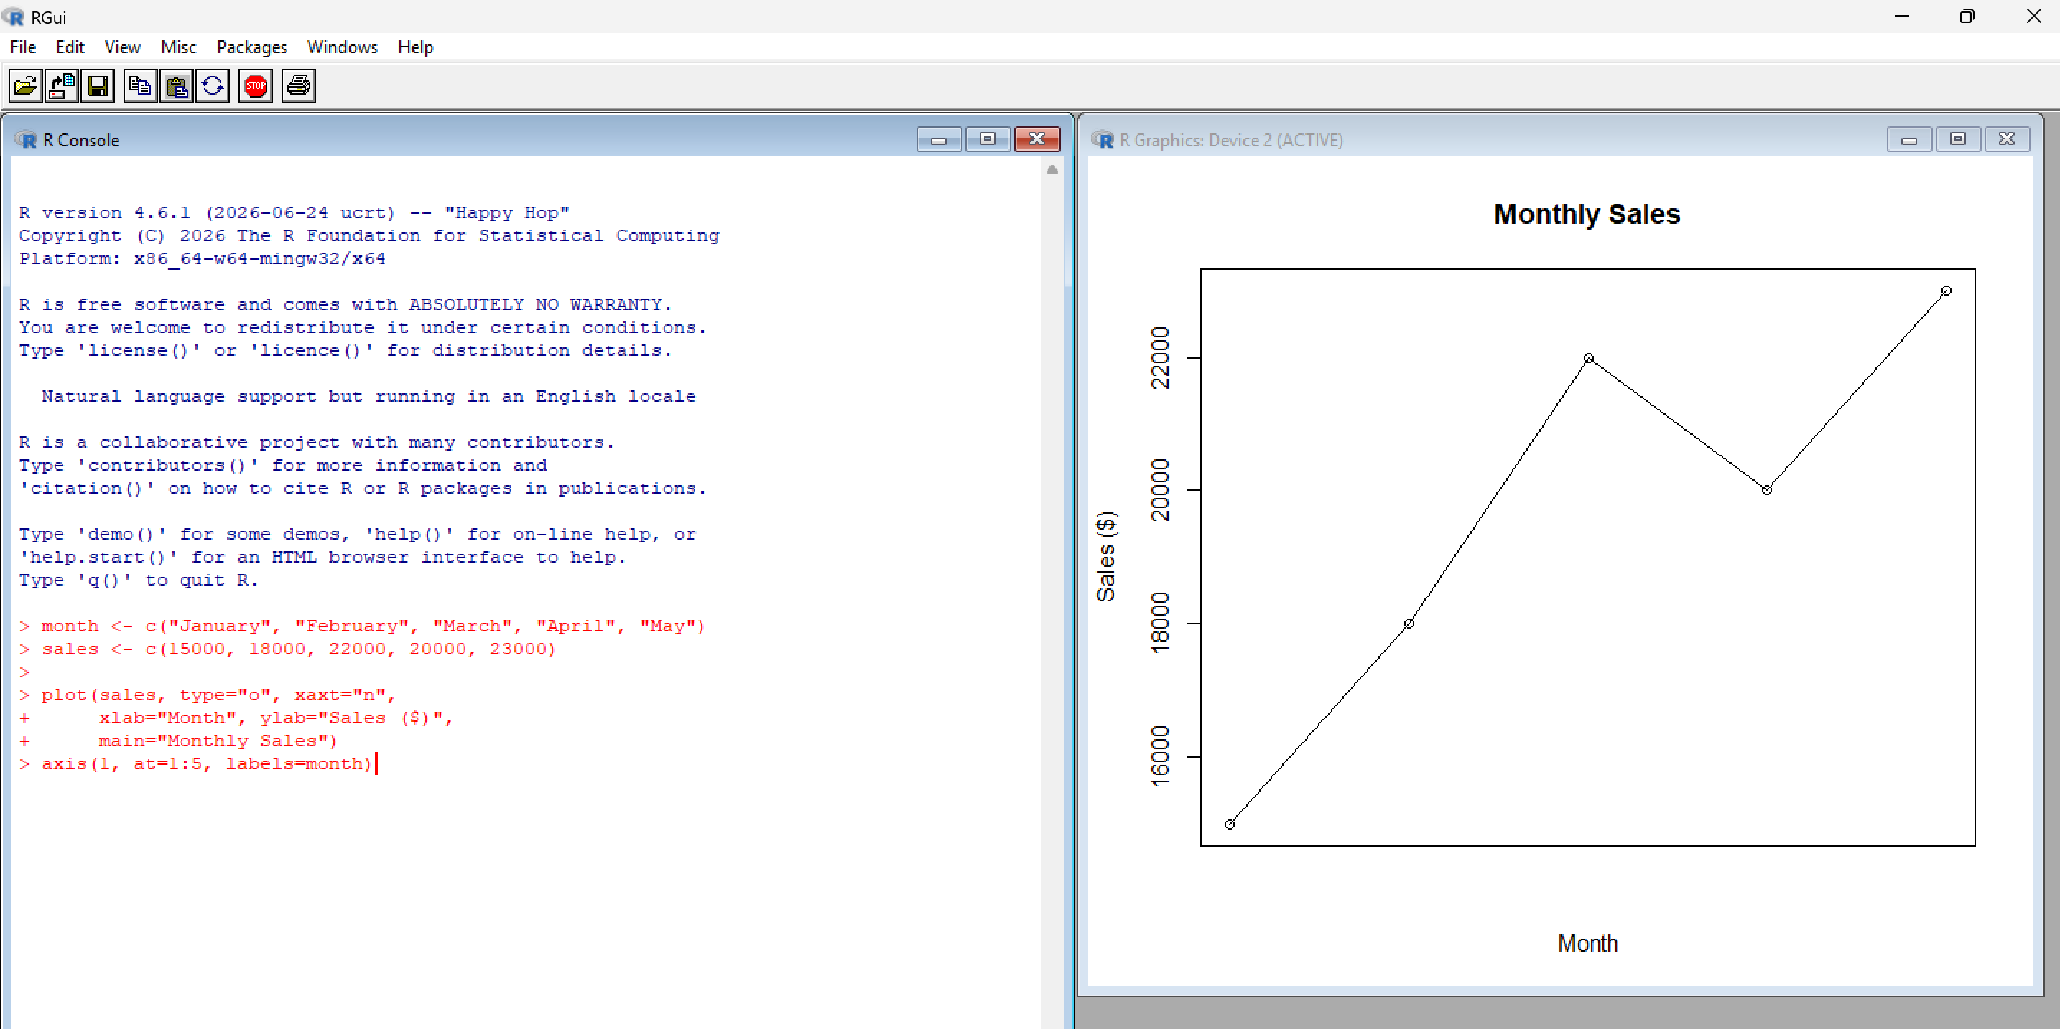
BAR CHART - TOP SELLING PRODUCTS
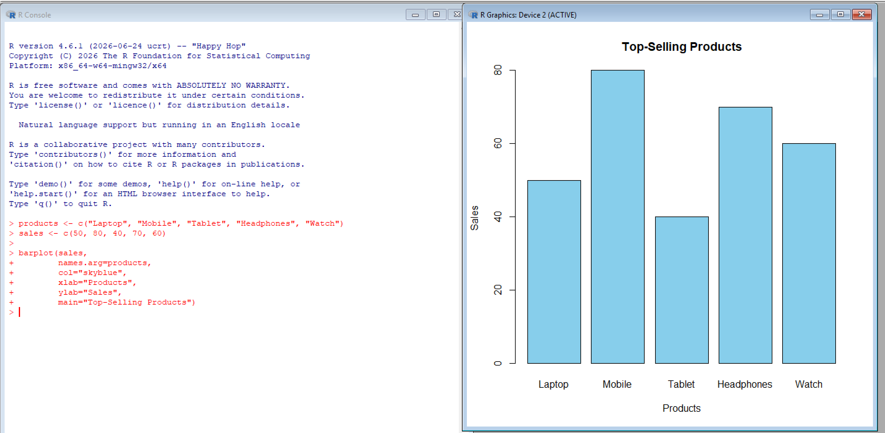

SCATTER PLOT – ADVERTISING BUDGET VS SALES
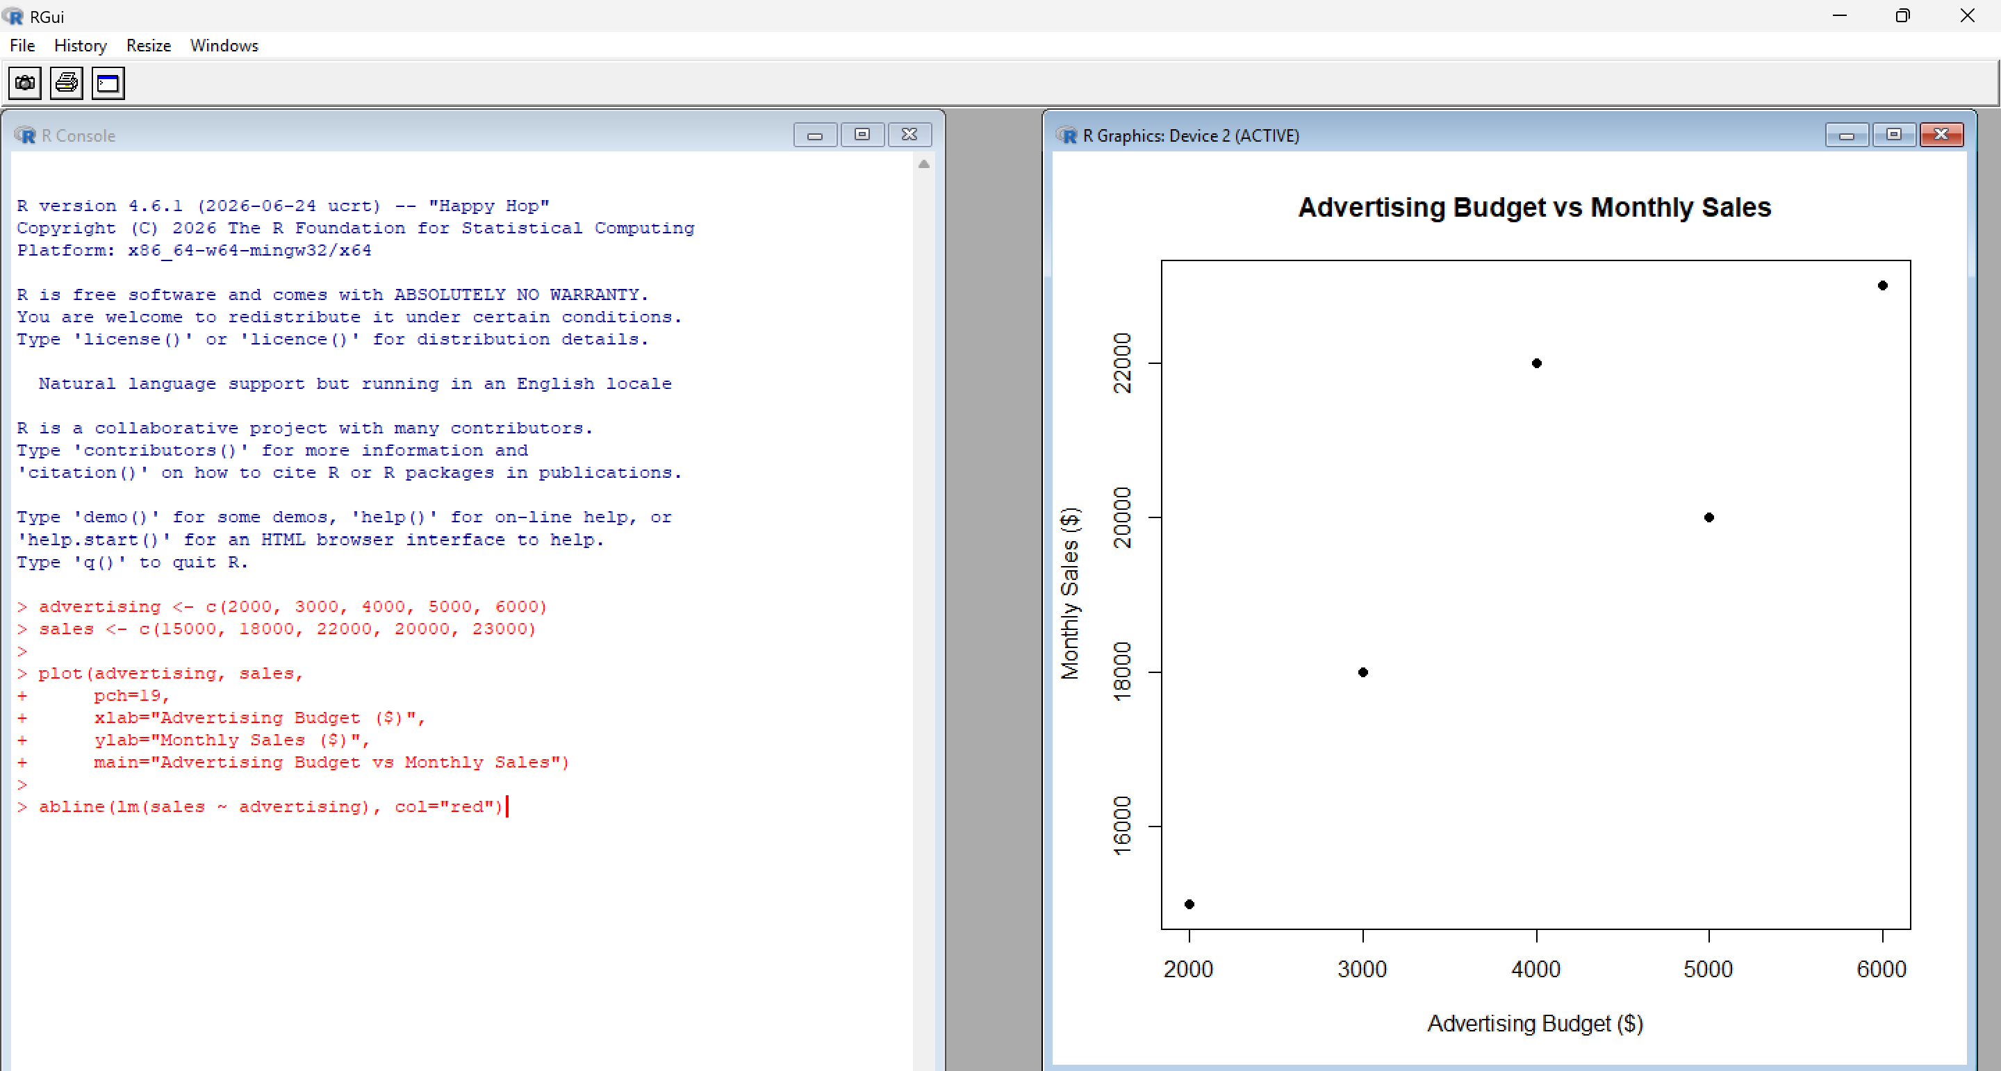
INTERACTIVE DASHBOARD - LINE CHART
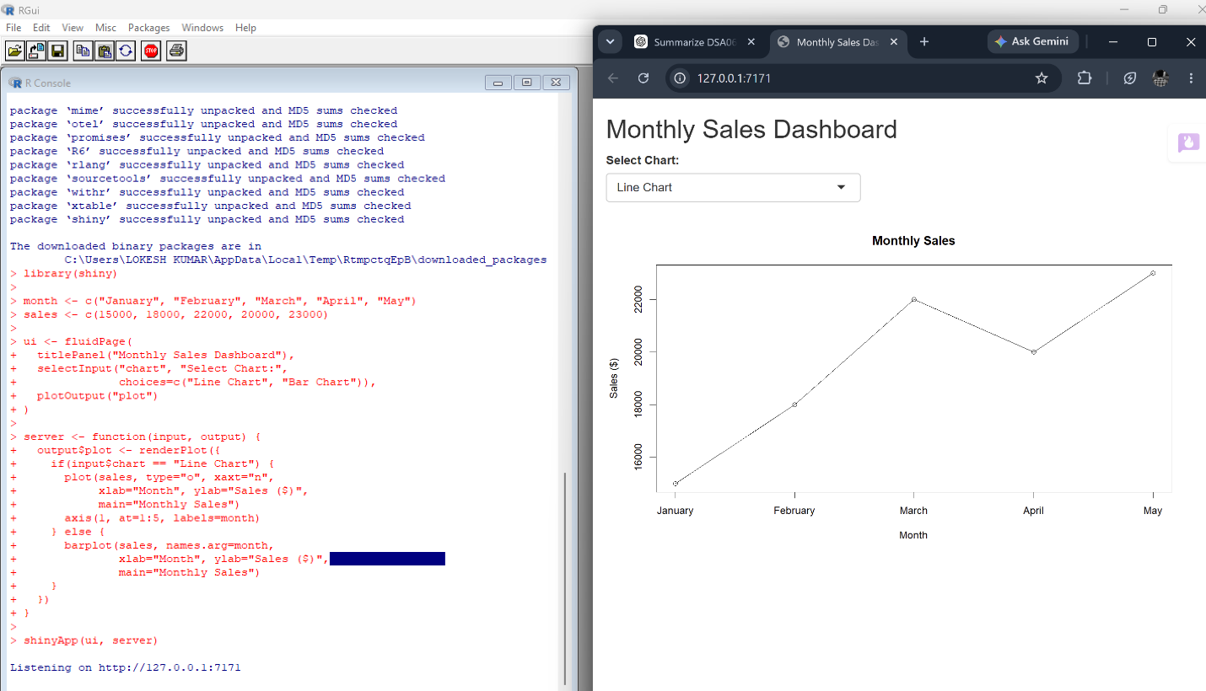

INTERACTIVE DASHBOARD- BAR CHART
